Rack RIA-8
A. Operation principle 2
1. General presentation 2
a) Front panel description 2
b) Rear panel description 2
2. Functionalities 3
a) Power supply 3
b) Sensors inputs 3
c) Analog output voltages 4
d) Protection of the HLS sensors 5
B. Acquisition and processing card 6
1. General presentation 6
a) Communication interface 6
b) Acquisition system 6
c) Central unit 7
2. Functionalities 8
a) Use of the serial link 8
b) Broaching of the RS 485 connectors 9
RS 232 serial link Rack/PC 9
d) RS 485 serial link Rack/PC 10
e) Chaining 11
C. Extension card option 12
1. General presentation 12
a) Broaching of the HE 10-26pts connectors 12
b) Example of connection with a TAP-EBC Rack 13

RIA-8 rack

Operation principle

General presentation
The RIA-8 rack is devoted to supply, acquire, process, save and/or transmit data coming from several sensors.
It is a 2U 19’’ rack with handles and securing squares. It can supply up to eight sensors (capacitive, inductive, temperature,...)

Front panel description
        - Supply voltage lights
        - Input connectors for sensors C1 up to C8
        - Analog outputs connectors CC S1 up to 8 and CT S1 up to 8
        - 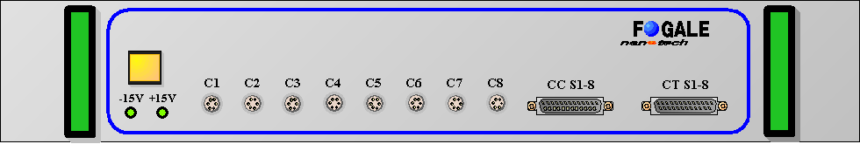Light switch for HLS protection

4

- 2 3

Rear panel description
        - Main input
        - Fuse and on/off switch
        - Inputs / Outputs compatible with TAP-EBC rack
        - Serial link : « upstream » connector (N-1)
        - Serial link : « downstream » connector (N+1)
4
2

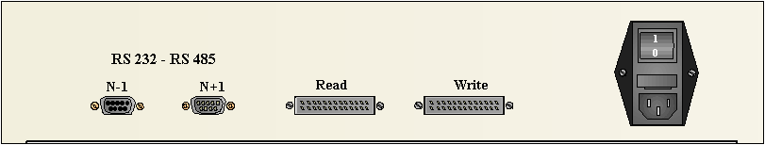
5
3
1

Functionalities

Power supply
The eight connectors (C1 up to C8) located on the RIA-8 rack provide a ±15 V regulated supply voltage.
Features :
- Maximum power : 30 Watt.
- Noise inferior to 5 mV_{p to p}.
Two green lights located on the front panel show the supply state.
The standard input voltage is 240 Volts 50/60 Hz but a 120 Volts 50/60 Hz or 110 Volts/50-60 Hz output voltage is also available.

Sensors inputs
The eight sensors inputs (C1 up to C8), which are available on the RIA-8 rack, include two measurement channels (VsC and VsT) and the ±15 V supply voltage.
VsC and VsT are differential inputs with a common negative input 0 Vm.

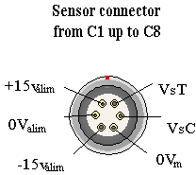

Analog output voltages
Each sensor output voltage is available on female DB 25 connectors (CT S1-8 and CC S1-8).
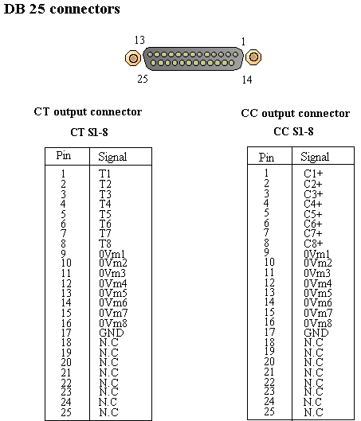
The pin nr 17 named «GND» is linked to the polarization network shared by all inputs and must be linked to the supply ground of a possible acquisition card.

Protection of the HLS sensors
The RIA-8 rack is equipped with a breaker which ensures the protection of the HLS sensors electrode against vessel flooding thanks to a reference voltage set in works according to the sensors measuring range.
Example : For a HLS sensor with 5-15 mm measuring range, the breaking voltage is set to –2.5 V, whereas it is set to –7 V for a 5-10 mm measuring range.
In the case of several sensors, if one wants to inhibite the protection of one or several sensor(s), one just has to open the rack and remove the strap corresponding to the concerned sensor (Figure 3).

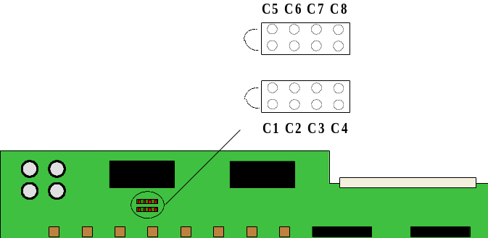

Figure 3

The reference voltage is only available on VsC channels.

When the water level is almost in contact with the electrode of a sensor, the supply voltage to C1 up to C8 is immediatly cut and the light switch is activated.
The sensors electrodes are thus preserved from electrolisys phenomenons.
In order to start up the rack, the water level inside the flooded vessel must be lowered and the light switch has to be pushed on or reactivated by the software via the RIA Micro card, which always remains supplied in such a situation.

Acquisition and processing card

General presentation

The RIA Micro card size is 100 mm x 160 mm. It can be inserted in a rack type RIA-8 and allows to acquire data delivered by the different sensors connected to the rack and to transmit these data to an external system via RS232 or RS485 serial link.

The card includes a 16 bits micro-controller and its functionalities are the following (see synoptic) :

Communication interface
Communications between cards are carried out under a slave – master principle through an electrical interface type RS485. Each card has a signal repeater function and includes a by-pass relay which automaticaly switches off the card in case of problem (supply failure for example). This type of interface allows to have a total network of maximum 1 km but we advise not to get over the half of this distance (i.e. 500 m) if the by-pass relay is used.
The card is equipped with two DB9 connectors : one female connector to the « upstream » network and one male connector to the « downstream » network. Connecting cables between cards have 5 conductors :

- two conductors receiving information from the network managing system,
- two conductors sending information to the network managing system,
- one ground conductor.

The transmission speed is set in standard to 115 200 bits/second but can be increased up to speeds around the megabit per second if it is required by the application complexity.

Acquisition system
The acquisition system consists of a 16 bits convertor. Its features are the following :
- Twenty differential inputs as follows : 16 channels accessible by connectors on the rack front panel, 2 channels respectively connected to a nil voltage and a reference voltage close to 10 volts, 2 additional channels for a possible extension.
- Voltage range : ±10 volts
- Input filters : 1st order low-pass filter set to 1600 Hz.
- Digitization time on one channel : 50 µs
- Integral linearity : ±0,5 mV.
- Reference voltage drift : 2,5 ppm/°C and 5 ppm/1000 hours.

Central unit
- 80C196 processor with a 18.432 MHz quartz
- 488 octets internal RAM, 32 ko external RAM, 128 ko Flash EEPROM which can be erased and re-programmad on site according to eight 16 ko sections. The external RAM content can possibly be saved by a 3 or 4 Volt battery.
- 100 ms watchdog

Functionalities

Use of the serial link
The acquisition card has been designed to communicate either in RS232 or RS485/RS422 serial link.
The communication mode configuration is carried out by means of the ST2 strap located on the RIA Micro card .
Four transmission speeds are available on the RIA Micro card : between 1 200 and 115 200 Bauds. The desired transmission speed can be selected on the ST12 strap.

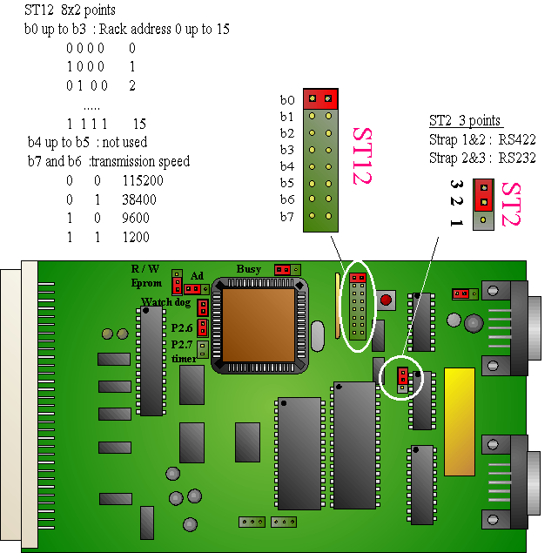

Broaching of the RS 485 connectors

Connector 3 : Sub D 9 points female connector (« upstream » network N-1)

Card view
1 | RX- | Entrée RS485
2 | RX+ | Entrée RS485
3 | TX+ | Sortie RS485
4 | TX- | Sortie RS485
5 | 0V
6,7,8,9 | NC

Sub D 9 points male connector (downstream network N+1)

Card view
1 | RX- | Sortie RS485
2 | RX+ | Sortie RS485
3 | TX+ | Entrée RS485
4 | TX- | Entrée RS485
5 | 0V
6,7,8,9 | NC

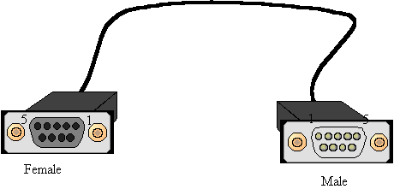RS 232 serial link Rack/PC

 | PC |  |  | Rack
 | female DB9 | PC view |  | male DB9 | Rack view
2 | RX | Output | 4 | TX | Output
3 | TX | Input | 1 | RX | Input
5 | GND |  | 5 | GND

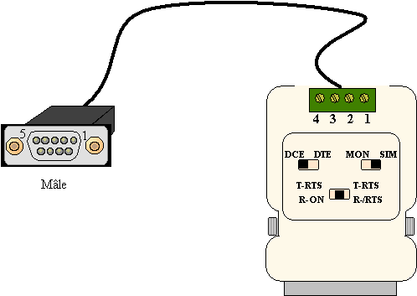RS 485 serial link Rack/PC

Rack | PC | Cable color
Male DB9 | RS 232/485  convertor
2 RX- | 1 TX+ | red
1 RX+ | 2 TX- | brown
3 TX- | 3 RX+ | orange
4 TX+ | 4 RX- | yellow
5 GND |  | green

Chaining
The RIA-8 racks can be chained together so as to acquire and process the data from a network including more than eight sensors.
For this application the racks addresses must be changed. The first rack will use the address nr 1 and will be connected to the computer via the N-1 connector. The address of each following rack is determined by the bits b0 up to b3 of the ST12 strap. The transmission speed must be the same for all the racks.

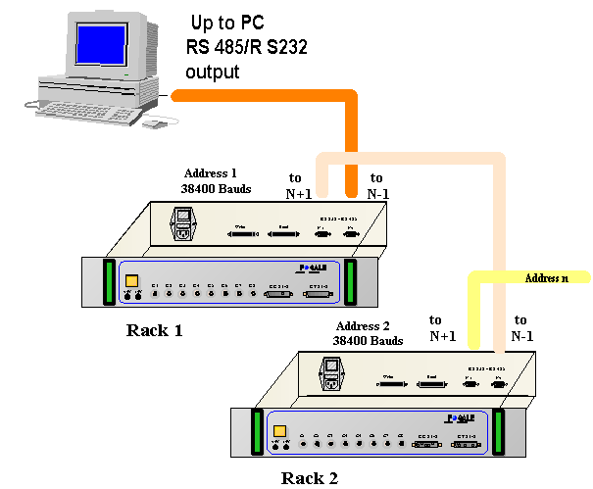

Extension card option

General presentation
The extension card option is foreseen for racks equipped with the RIA Micro card and allows to add 16 inputs /outputs.
This card is compatible with TAP-EBC racks.
The network managing system can then monitor 8 actuators such as electro-taps and/or control their state through the network.

Broaching of the HE 10-26pts connectors

HE 10-26 pts connector HE 10-26 pts connector
Read Write
1 | GND |  | 1 | GND
2 | GND |  | 2 | GND
3 | GND |  | 3 | GND
4 | N.C |  | 4 | N.C
5 | +12 V |  | 5 | +12 V
6 | N.C |  | 6 | N.C
7 | N.C |  | 7 | N.C
8 | Input 0 |  | 8 | Output 0
9 | Input 1 |  | 9 | Output 1
10 | Input 2 |  | 10 | Output 2
11 | Input 3 |  | 11 | Output 3
12 | Input 4 |  | 12 | Output 4
13 | Input 5 |  | 13 | Output 5
14 | Input 6 |  | 14 | Output 6
15 | Input 7 |  | 15 | Output 7
16 | Input 8 |  | 16 | Output 8
17 | Input 9 |  | 17 | Output 9
18 | Input 10 |  | 18 | Output 10
19 | Input 11 |  | 19 | Output 11
20 | Input 12 |  | 20 | Output 12
21 | Input 13 |  | 21 | Output 13
22 | Input 14 |  | 22 | Output 14
23 | Input 15 |  | 23 | Output 15
24 | N.C. |  | 24 | N.C.
25 | GND |  | 25 | GND
26 | GND |  | 26 | GND

Example of connection with a TAP-EBC Rack
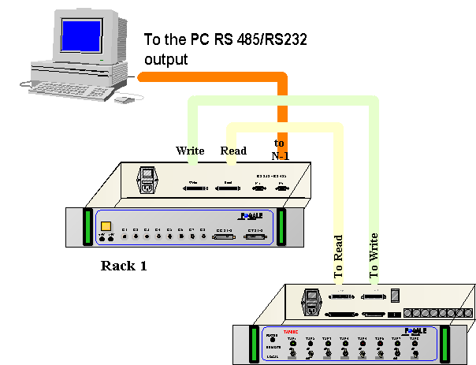
TAP-EBC Rack

